**Project Report**

**CALORIE TRACKER WEBSITE**  
*Maryam Albakhiet ID #1  
Nikita Goyal ID #10  
Lab ID #6*

Github link: <https://github.com/Nikii1118/Web-Programming-/tree/master/Project>

1. **Motivation**

We are consuming a lot of unhealthy food and to keep track of our health we need to know what type of food we are consuming each day. How many calories we are intake. So, our Calorie Counter Website will help the users to keep track of their daily calories intake. Hopefully by that, they can watch their weight and live healthier lives with our website.

1. **OBJECTIVE**

Building the calories counter website which includes certain features:

* recipe generator
* searching food calories
* calories counter
* BMI calculator
* keto diet
* Exercise

1. **Significance:**

This website will be very useful for users who want to easily track of their weight and can know more things about their health and it give suggestions to users about the recipe. This website also provides them various exercise videos where they can watch it and do that exercises to keep their body in shape.

This website tells the user how much calories are extra and how much they need according to their height and weight. This helps the user to live a healthy lifestyle and keep track of its healthy lifestyle.

1. **System Architecture**

The System architecture consists of:

1. Presentation Layer
2. Application Logic layer
3. Data Access Layer

All the three layers combined plays an important role in a making a website.

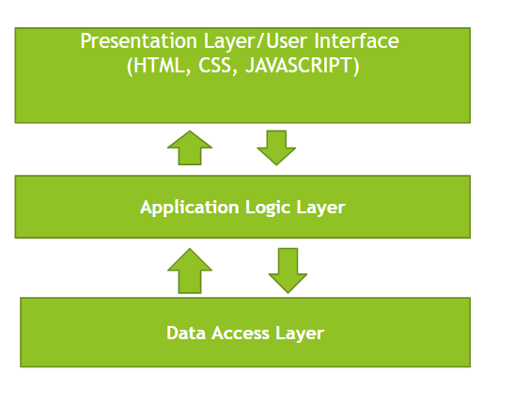

1. **Technical Stack**

Technologies Used:

5

1. **API USED:**

* Nutritionix API
* TheMealDB API

1. **Implementation**

To implement this website, we have used the basic html, CSS and Javascript and bunch of API’s to get the more out

**Home Page**

This page contains information about the website.

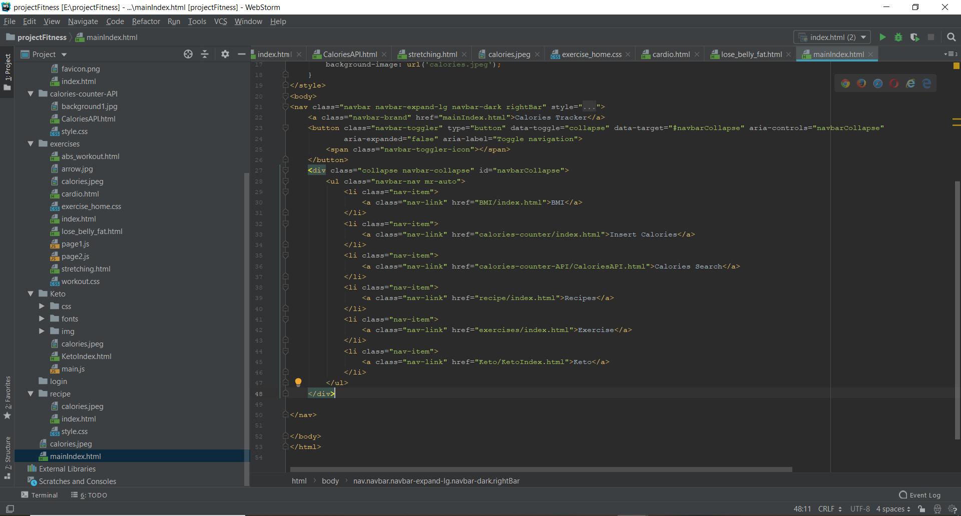

**BMI PAGE**

When we click on BMI page, the BMI calculator, Calories Calculator and Fat Calculator.

* It tells you whether you are obese or not
* It tells you how much calories your intake in a day should
* How much extra fat you have in your body?

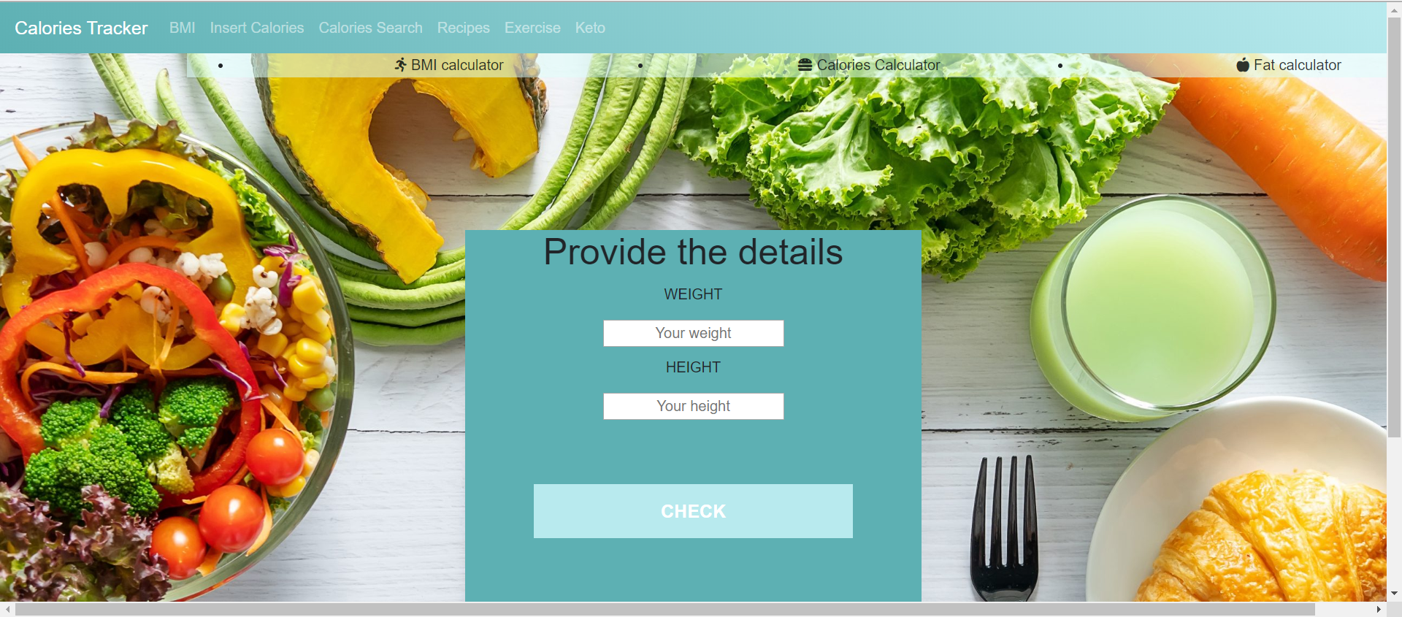

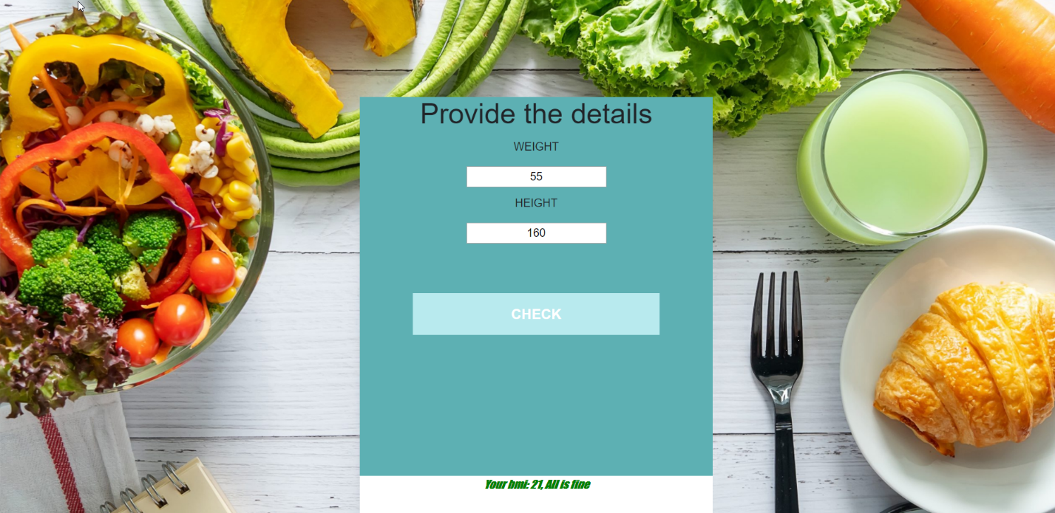

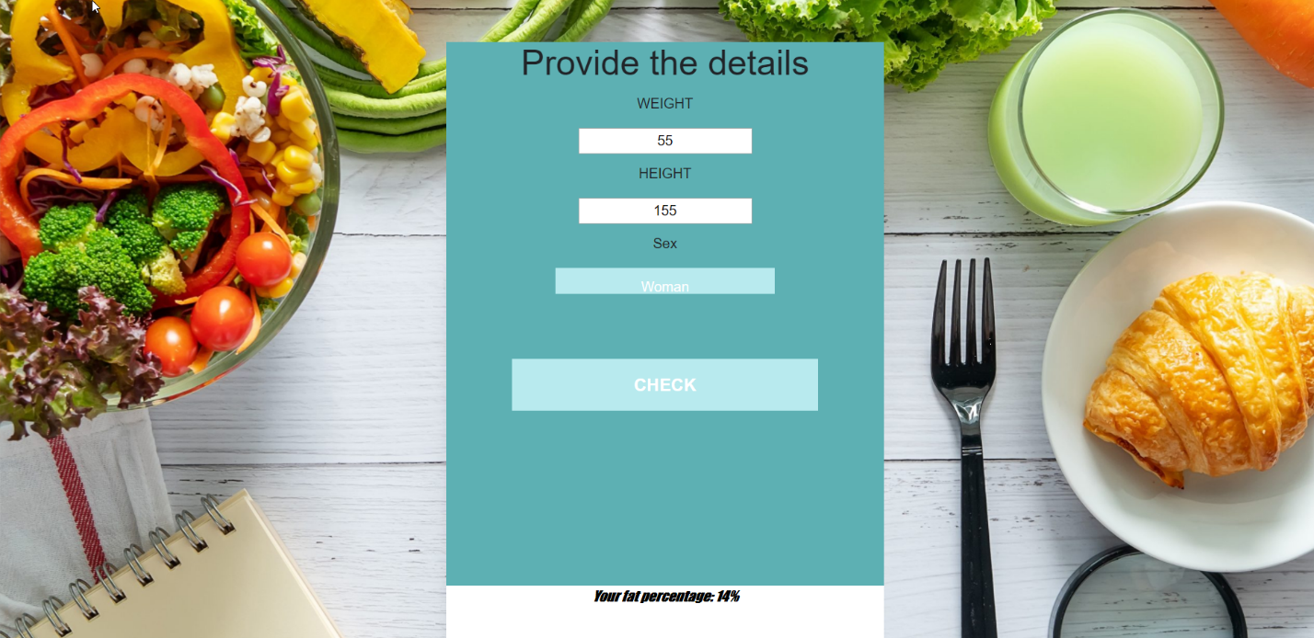

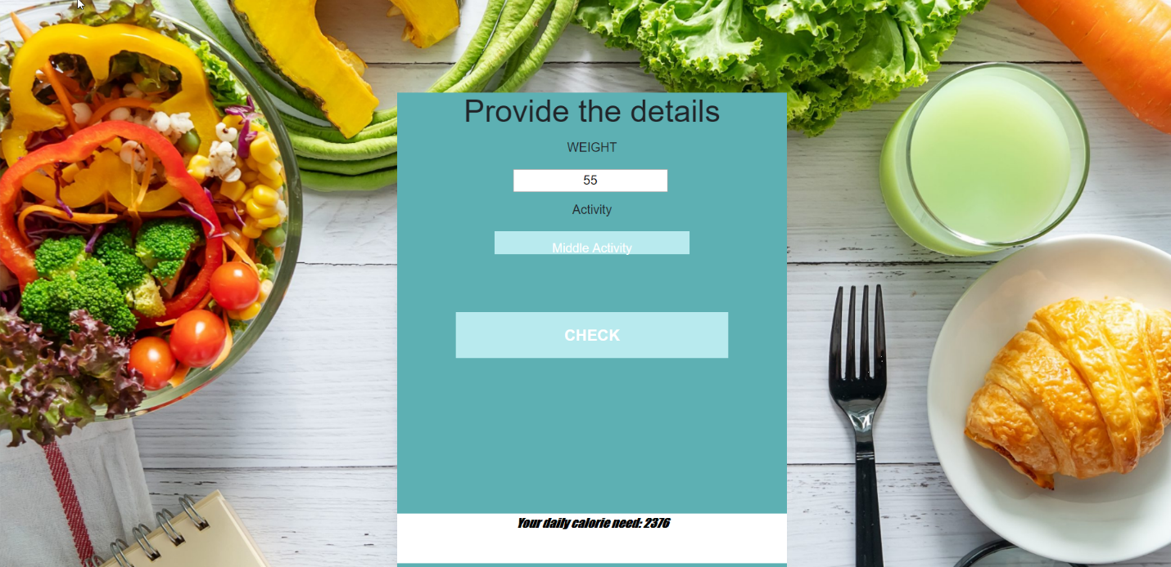

**Calories Search**

You can search anykind of food item it will tell you how much calories,fats,protein and carbohydrates it has in the form of line chart.

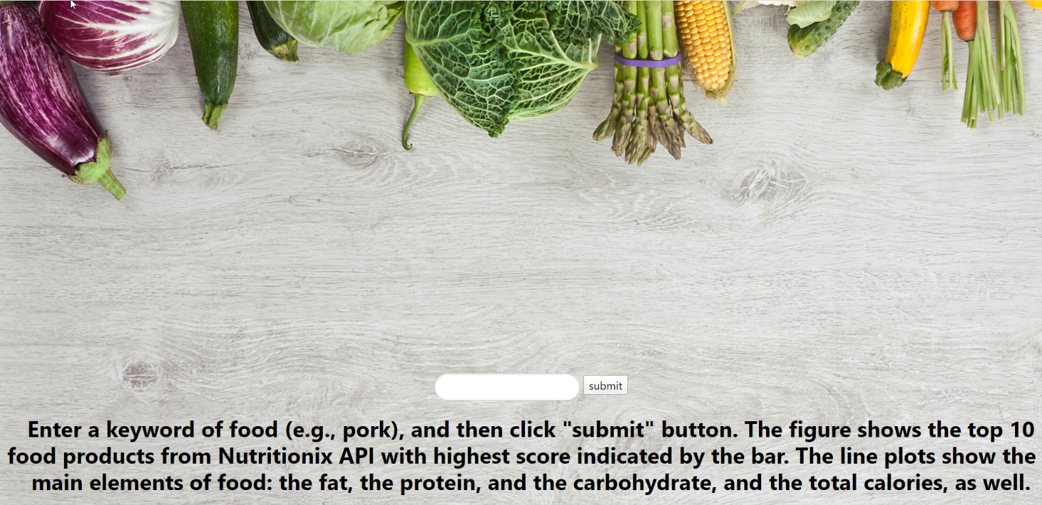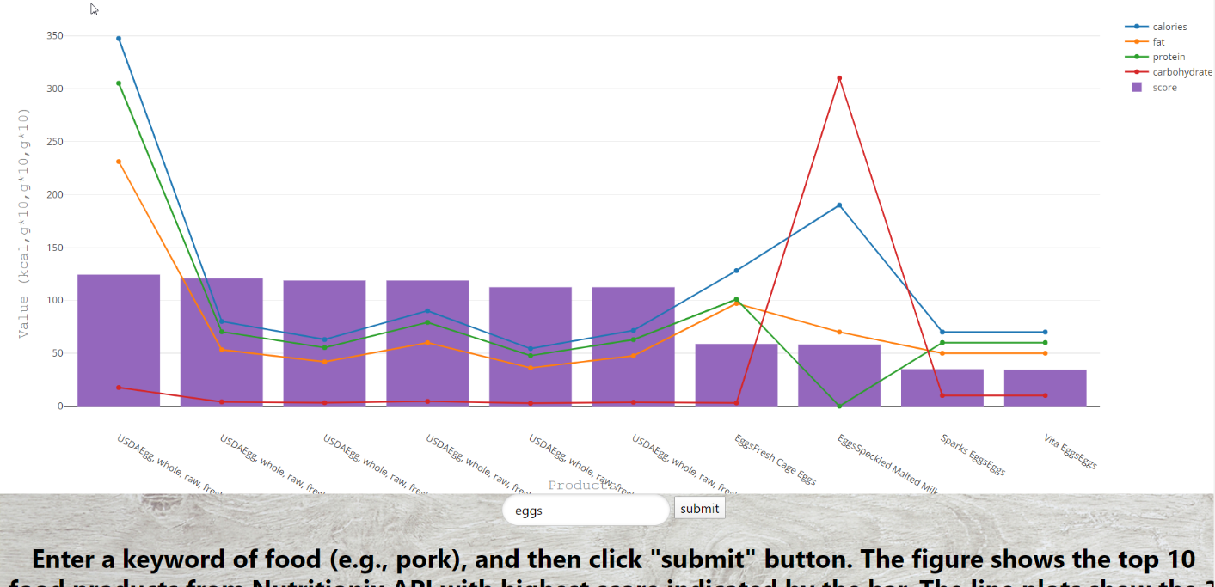

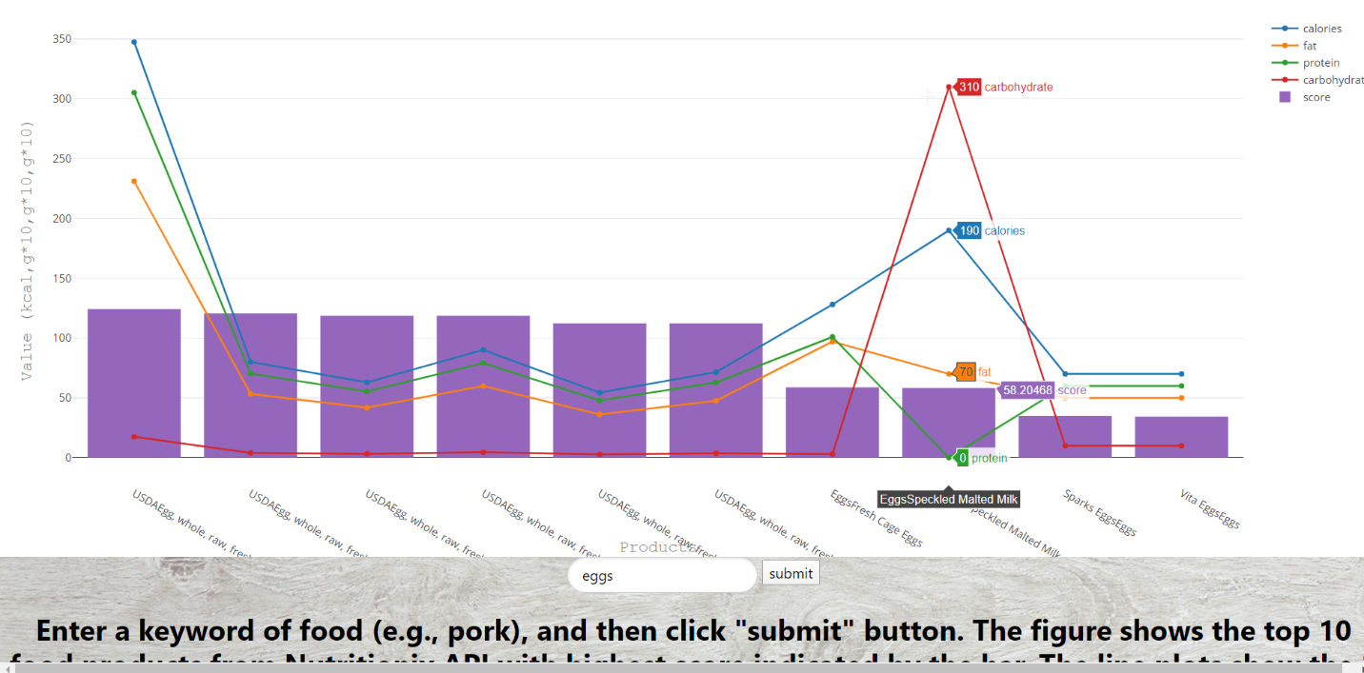

**Exercise page:**

It shows you stretching ,abbs workout,cardio and loose belly fat related all the exercise which are fetched from youtube and categorised.

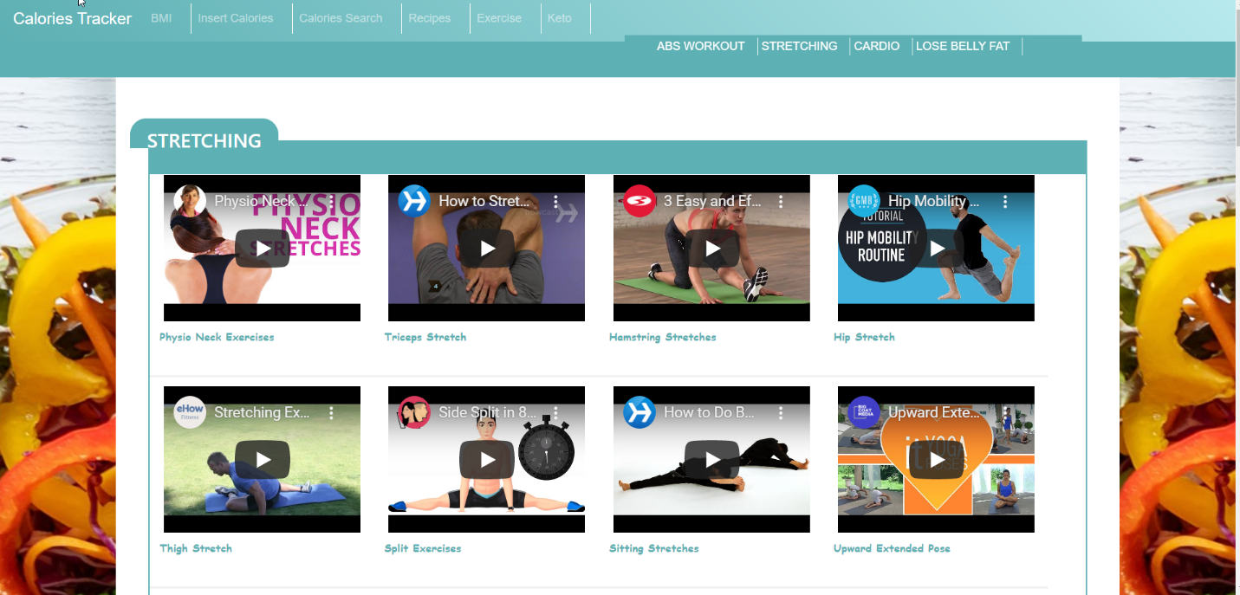

**Insert Calories Page**

You can get total of calories by filling all the details like how many carbs,calories and protiens you have take and can get the total.That will help you decide how much quantity is good.

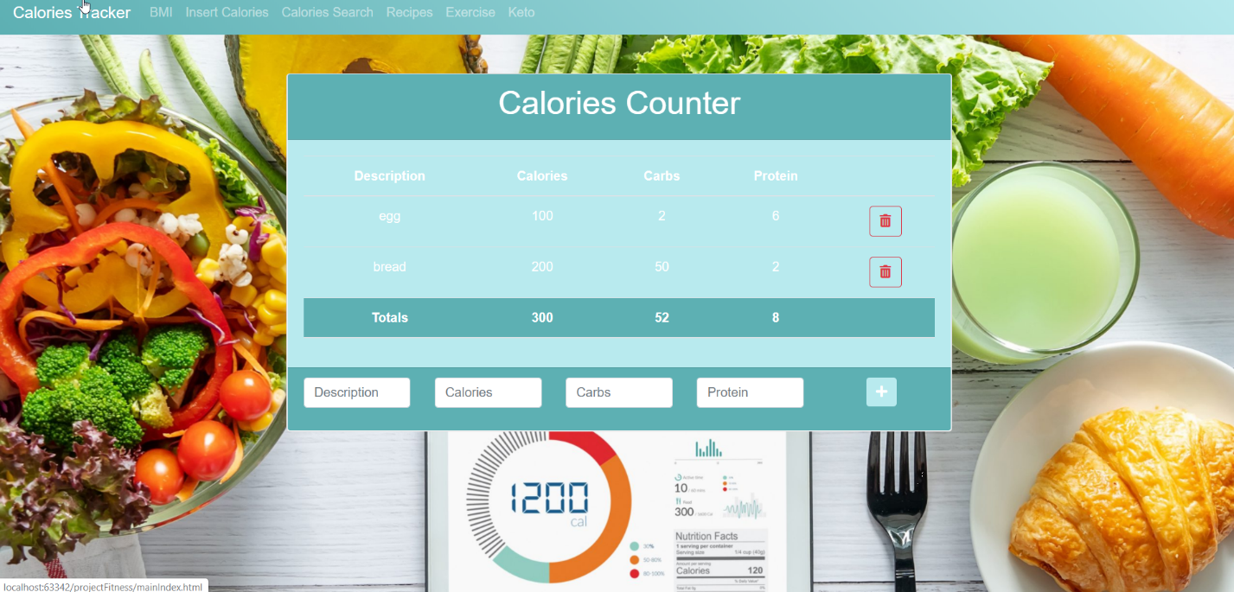

**Recipe Generator**

If you are not able to decide what to eat on the particular day. What is healthy recipe to eat. This is a page you should land on. They pick random recipes for you and you can just fill in what type of food you want to eat it will fetch you the recipe.

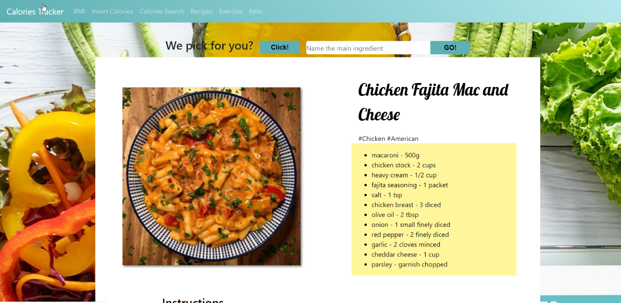

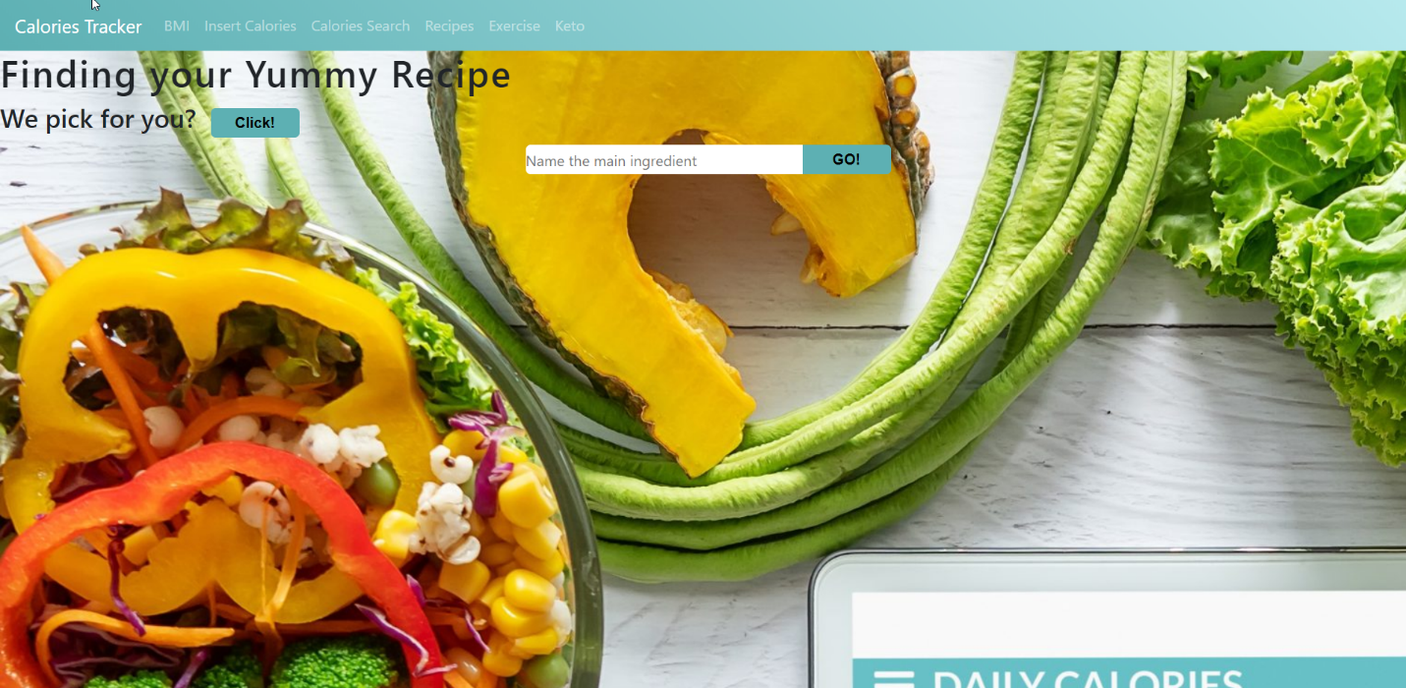

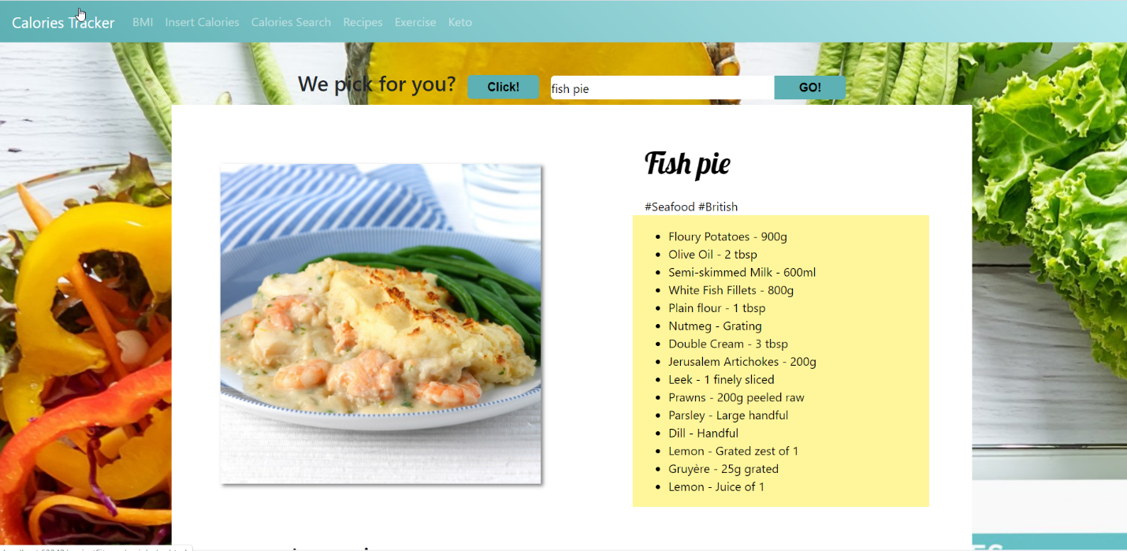

**Keto diet Page**

It is a blog page in which you can get every information about the keto diet. What is keto diet ,what type of food we should eat to follow the diet and many more.

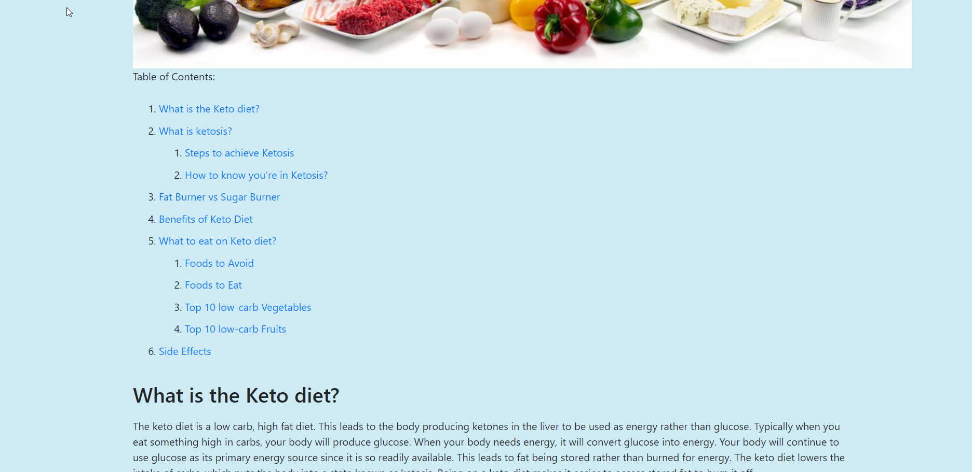

1. **Contribution**

We evenly divided the project pages to build between me and my teammate and then we will collaborate the whole project together. Since, we are only two members in a team. We will tryto do our best to achieve our goals for this project.

1. **Improvement from Increment-2**

We built separate pages of the website. We combined all together to form a full website.

1. **References**

* <https://www.webmd.com/diet/healthtool-food-calorie-counter>
* <https://play.google.com/store/apps/details?id=com.myfitnesspal.android&hl=en_US>
* <https://www.my-calorie-counter.com/>
* <https://www.calculator.net/calorie-calculator.html>
* <https://www.cancer.org/healthy/eat-healthy-get-active/take-control-your-weight/calorie-counter-calculator.html>
* <https://www.myfitnesspal.com/>